

**PAF-Karachi Institute of Economics and Technology College of Computing and Information Sciences**

**Object Oriented Programming**

**Assignment - 2**

***Name: Shahmeer khan.***

***Class ID: 106278.***

***Student ID: 12113.***

**Instruction:**

### Create a **word document** which contains each question’s solution with screen shot of output.

* Must attempt all questions by yourself, in case of **copied** solutions your assignment will marked **ZERO.**
* Submit softcopy on **Google classroom** before deadline.

## Save your word document with name: [Student Name Student ID] Submission Deadline: 18/04/2021

**Question – 1 [WINDOWS FORM BASED ] [5 marks]**

Create a quiz application for two types of student “junior students / senior students”.

For both you have to create two levels of quiz question. [High/medium]. Each level contains 5 quiz question and each question contains 3 answers options it’s very simple, now run your mind to create GUI and:

Apply OOP concepts:

1: classes

2: Constructor overloading

3: static keyword

4: methods

Use an appropriate GUI controls to create a best design from your side.

Show the correct answers and wrong answers at the end of the quiz program.

***Inputted Code:***

***Login Form Code:***

using System;

using System.Collections.Generic;

using System.ComponentModel;

using System.Data;

using System.Drawing;

using System.Linq;

using System.Text;

using System.Threading.Tasks;

using System.Windows.Forms;

namespace _12113_Shahmeer_s_OOP_LAB_ASSIGNMENT_2

{

public partial class Login_Main : Form

{

public Login_Main()

{

InitializeComponent();

}

private void label1_Click(object sender, EventArgs e)

{

}

private void Cancel_Button_Click(object sender, EventArgs e)

{

Close();

}

private void Login_Button_Click(object sender, EventArgs e)

{

DAO Login_work = new DAO();

Login_work.Login(Name_Textbox.Text, TypeCombo.Text, ID_textbox.Text, Password_Textbox.Text);

}

}

}

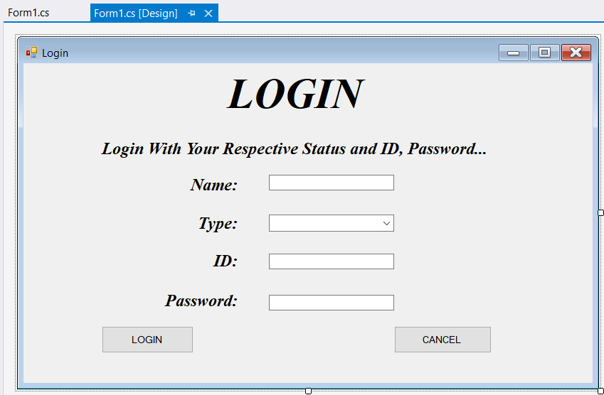

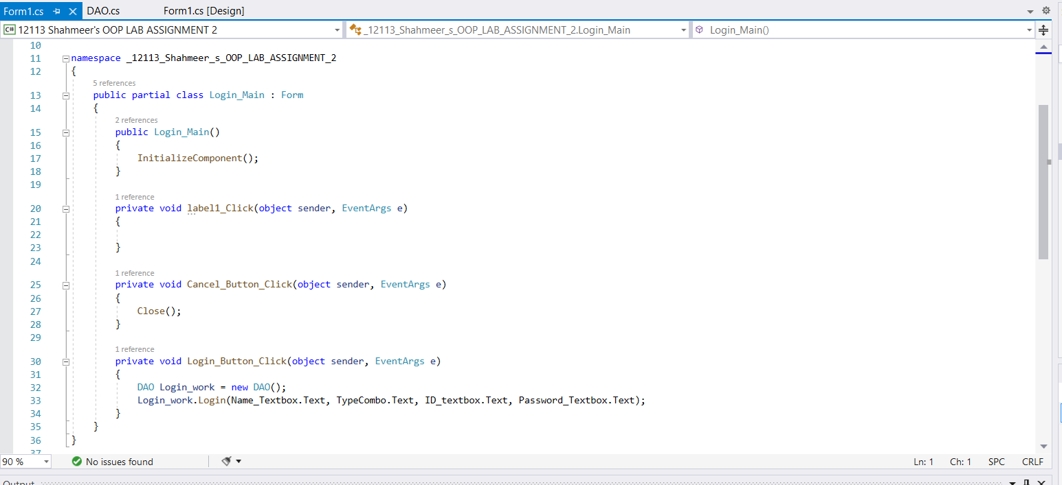

***\*The functioning of this form will be according to a database data table and the database’s functioning is done in the DAO class.***

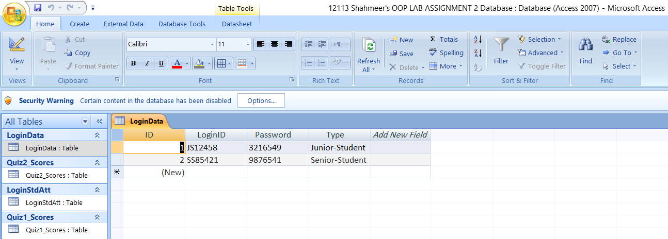

***DAO Class Code:***

using System;

using System.Collections.Generic;

using System.Linq;

using System.Text;

using System.Threading.Tasks;

using System.Windows.Forms;

using System.Data;

using System.Data.OleDb;

namespace _12113_Shahmeer_s_OOP_LAB_ASSIGNMENT_2

{

class DAO

{

private string Connection = @"Provider=Microsoft.ACE.OLEDB.12.0;Data Source=D:\Kiet 2nd Semester\OOP LAB\OOP LAB ASSIGNMENT 2\12113 Shahmeer's OOP LAB ASSIGNMENT 2 Database.accdb";

private DataTable LoginData = new DataTable();

private static string name, type, type_id;

public int Q1q1 = 0, Q1q2 = 0, Q1q3 = 0, Q1q4 = 0, Q1q5 = 0;

public int Q1;

public int Q2q1 = 0, Q2q2 = 0, Q2q3 = 0, Q2q4 = 0, Q2q5 = 0;

public int Q2;

public void Login(string Name, string Type, string ID, string Password)//polymorphism type of contructor overloading

{

string Querry = "Select * From LoginData";

OleDbConnection CONNECTION = new OleDbConnection(Connection);

CONNECTION.Open();

OleDbCommand CMD = new OleDbCommand(Querry, CONNECTION);

OleDbDataAdapter DataAdapter = new OleDbDataAdapter(CMD);

DataAdapter.Fill(LoginData);

if (ID == LoginData.Rows[0]["LoginID"].ToString() && Password == LoginData.Rows[0]["Password"].ToString() && Type == LoginData.Rows[0]["Type"].ToString())

{

Junior_Quiz_1 JQ1 = new Junior_Quiz_1();

JQ1.Show();

CONNECTION.Close();

StsLoginAttState(Name, Type, ID);

}

else if(ID == LoginData.Rows[1]["LoginID"].ToString() && Password == LoginData.Rows[1]["Password"].ToString() && Type == LoginData.Rows[1]["Type"].ToString())

{

Senior_Quiz_1 SQ1 = new Senior_Quiz_1();

SQ1.Show();

CONNECTION.Close();

StsLoginAttState(Name, Type, ID);

}

else

{

MessageBox.Show("Invalid ID or/and Password");

CONNECTION.Close();

}

}

public void StsLoginAttState(string Name, string Type, string ID)

{

name = Name;//to save the textboxes values in static strings to be used for another work of data insertion

type = Type;//to save the textboxes values in static strings to be used for another work of data insertion

type_id = ID;//to save the textboxes values in static strings to be used for another work of data insertion

//This method will work as attendance marker like it will save the data through name, ID textbox and comboxbox into the data base

//whichever student will try to login for the quiz automatically

string querry = "Insert into LoginStdAtt([Name],[Type],[Type_ID],[Attendance]) values ('" + Name + "', '" + Type + "', '" + ID + "', '" + "P" + "')";

CONNECTION(querry);

}

public void CONNECTION(string QUERRY)

{

OleDbConnection CON = new OleDbConnection(Connection);

OleDbCommand cmd = new OleDbCommand(QUERRY, CON);

CON.Open();

int a = cmd.ExecuteNonQuery();

if (a <= 0)

{

MessageBox.Show("Students Data Insertion Failed!!!");

}

CON.Close();

}

public int Quiz1()

{

Q1 = Q1q1 + Q1q2 + Q1q3 + Q1q4 + Q1q5;

return Q1;

}

public int Quiz2()

{

Q2 = Q2q1 + Q2q2 + Q2q3 + Q2q4 + Q2q5;

return Q2;

}

public void Quiz1_Marks_Insertion()

{

int Q1 = Quiz1();

string QUERRY = "Insert into Quiz1_Scores([Name],[Type],[Type_ID],[Scores]) values ('" + name + "', '" + type + "', '" + type_id + "', '" + Q1.ToString() + "')";

CONNECTION(QUERRY);

}

public void Quiz2_Marks_Insertion()

{

int Q2 = Quiz2();

string QUERRY = "Insert into Quiz2_Scores([Name],[Type],[Type_ID],[Scores]) values ('" + name + "', '" + type + "', '" + type_id + "', '" + Q2.ToString() + "')";

CONNECTION(QUERRY);

}

}

}

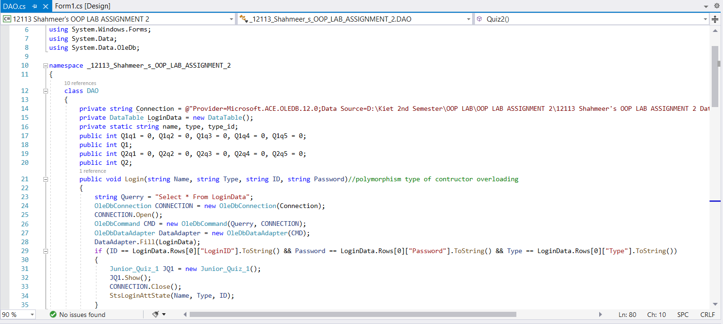

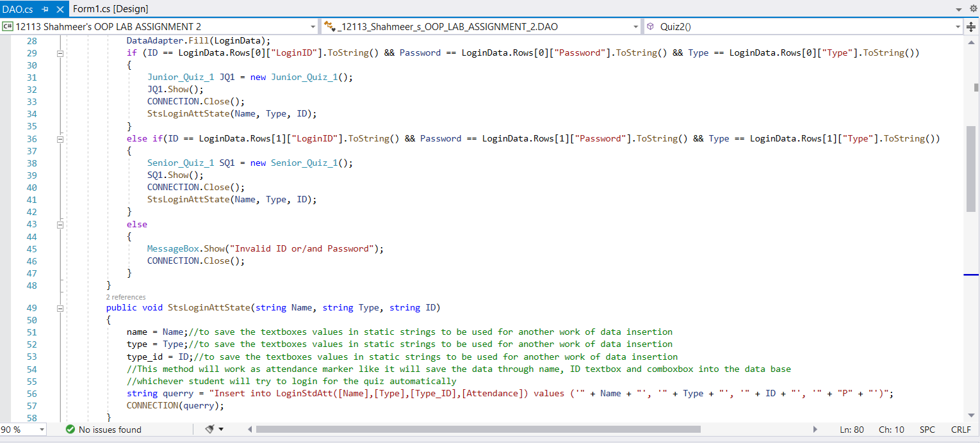

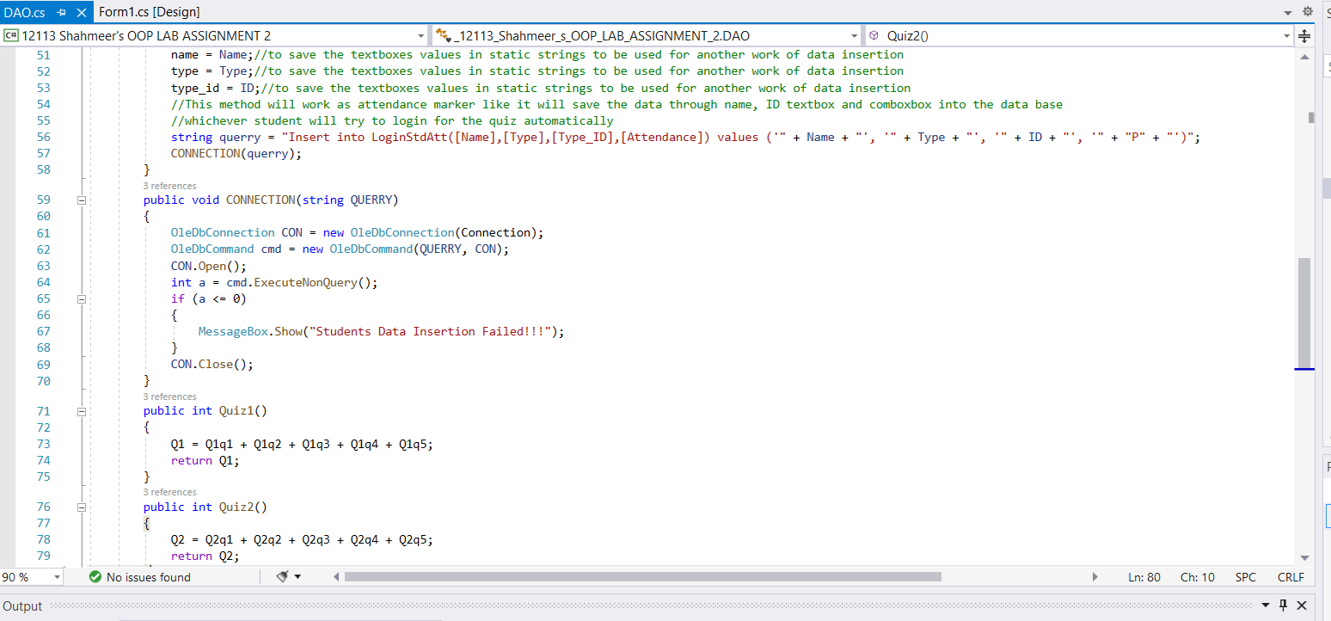

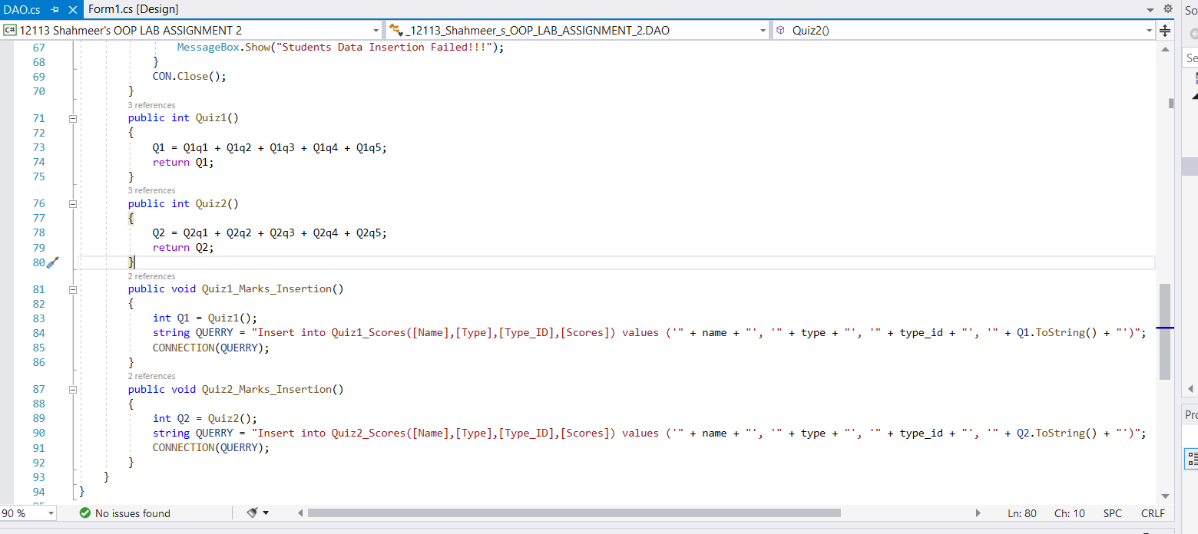

***Junior Quiz 1 Form:***

using System;

using System.Collections.Generic;

using System.ComponentModel;

using System.Data;

using System.Drawing;

using System.Linq;

using System.Text;

using System.Threading.Tasks;

using System.Windows.Forms;

namespace _12113_Shahmeer_s_OOP_LAB_ASSIGNMENT_2

{

public partial class Junior_Quiz_1 : Form

{

public Junior_Quiz_1()

{

InitializeComponent();

}

private void button1_Click(object sender, EventArgs e)

{

Quiz1_Checker();

Junior_Quiz_2 JQ2 = new Junior_Quiz_2();

JQ2.Show();

}

Login_Main Lm = new Login_Main();

public void Quiz1_Checker()

{

DAO JQW1 = new DAO();

if (F5.Checked == true)

{

JQW1.Q1q1 += 1;

}

else

{

JQW1.Q1q1 += 0;

}

if (Distance.Checked == true)

{

JQW1.Q1q2 += 1;

}

else

{

JQW1.Q1q2 += 0;

}

if (Liquid.Checked == true)

{

JQW1.Q1q3 += 1;

}

else

{

JQW1.Q1q3 += 0;

}

if (_1939.Checked == true)

{

JQW1.Q1q4 += 1;

}

else

{

JQW1.Q1q4 += 0;

}

if (_1.Checked == true)

{

JQW1.Q1q5 += 1;

}

else

{

JQW1.Q1q5 += 0;

}

MessageBox.Show("Your Score in Medium level is " + JQW1.Quiz1());

JQW1.Quiz1_Marks_Insertion();

}

private void CloseButton_Click(object sender, EventArgs e)

{

Close();

}

}

}

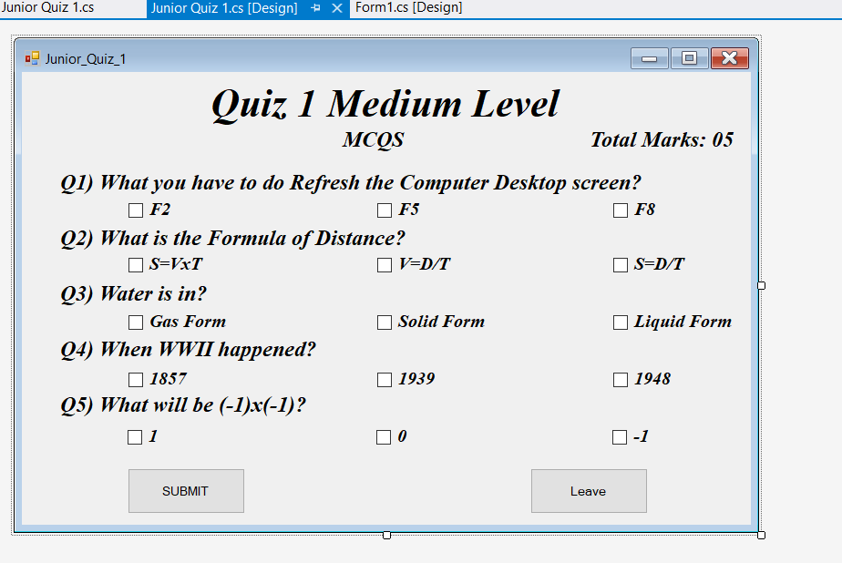

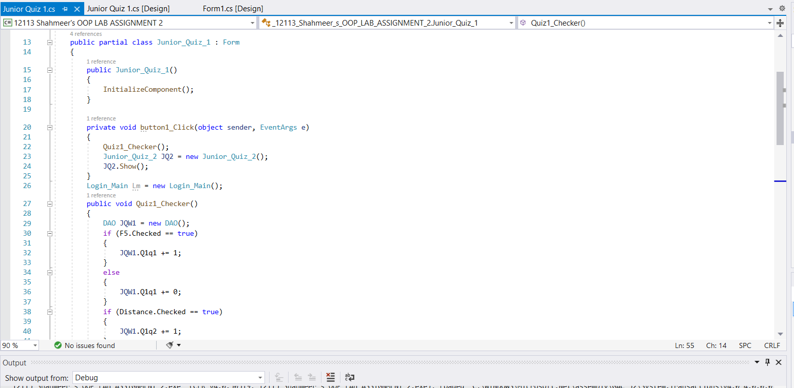

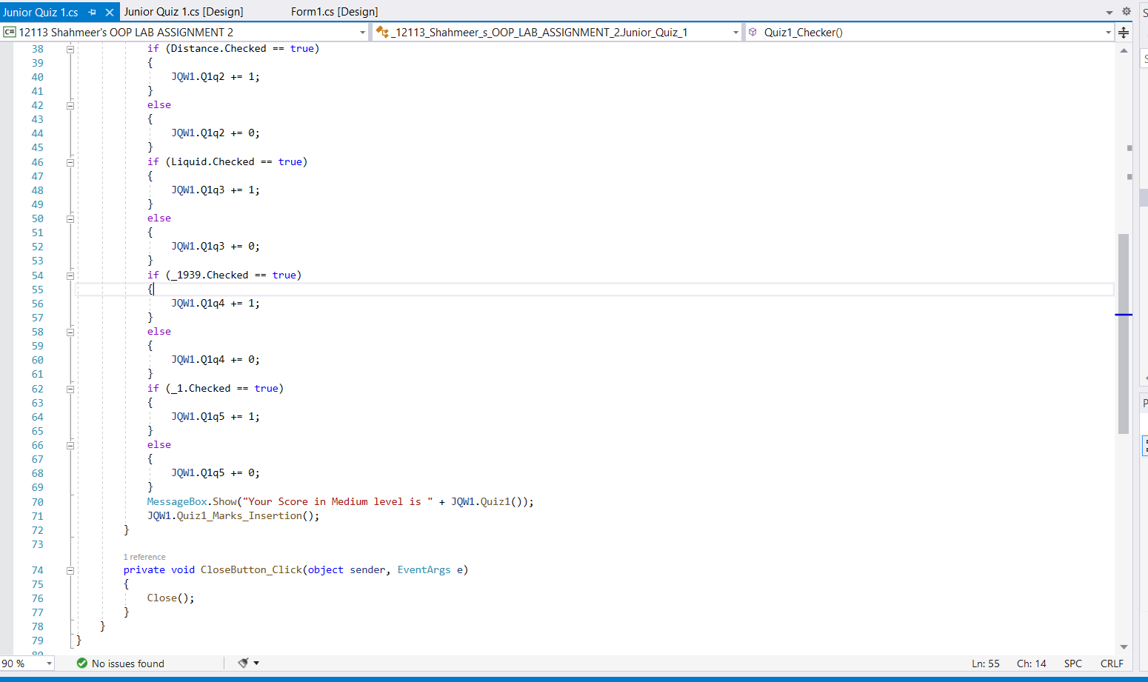

***Junior Quiz 2 Form:***

using System;

using System.Collections.Generic;

using System.ComponentModel;

using System.Data;

using System.Drawing;

using System.Linq;

using System.Text;

using System.Threading.Tasks;

using System.Windows.Forms;

namespace _12113_Shahmeer_s_OOP_LAB_ASSIGNMENT_2

{

public partial class Junior_Quiz_2 : Form

{

public Junior_Quiz_2()

{

InitializeComponent();

}

private void button1_Click(object sender, EventArgs e)

{

Quiz2_Checker();

Application.Exit();

}

public void Quiz2_Checker()

{

DAO JQW2 = new DAO();

if(ctrlcv.Checked == true)

{

JQW2.Q2q1 += 1;

}

else

{

JQW2.Q2q1 += 0;

}

if(GA.Checked == true)

{

JQW2.Q2q2 += 1;

}

else

{

JQW2.Q2q2 += 0;

}

if(__1.Checked == true)

{

JQW2.Q2q3 += 1;

}

else

{

JQW2.Q2q3 += 0;

}

if(Speed.Checked == true)

{

JQW2.Q2q4 += 1;

}

else

{

JQW2.Q2q4 += 0;

}

if(_4096.Checked == true)

{

JQW2.Q2q5 += 1;

}

else

{

JQW2.Q2q5 += 0;

}

MessageBox.Show("Your Score in high level is " + JQW2.Quiz2());

JQW2.Quiz2_Marks_Insertion();

MessageBox.Show("Correct Answers were: " + "\n*Medium Level:\nQ1: F5\nQ2: S=VxT\nQ3: Liquid Form\nQ4: 1939\nQ5: 1" +

"\n*High Level:\nQ1: ctrl c+ ctrlv\nQ2: 9.8 m/s^2\nQ3: -1\nQ4: m/s\nQ5: -4096");

}

private void CloseButton_Click(object sender, EventArgs e)

{

Close();

}

}

}

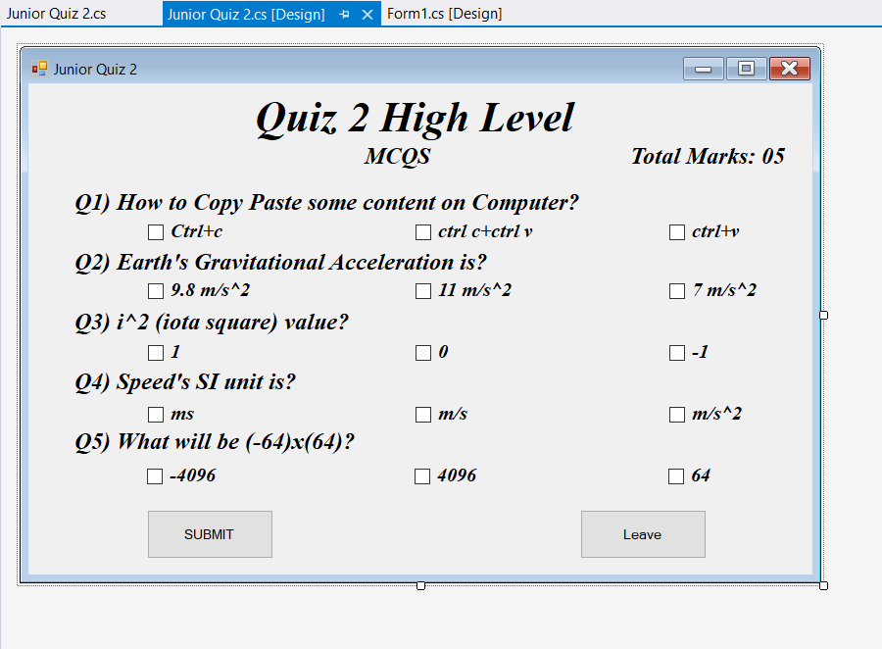

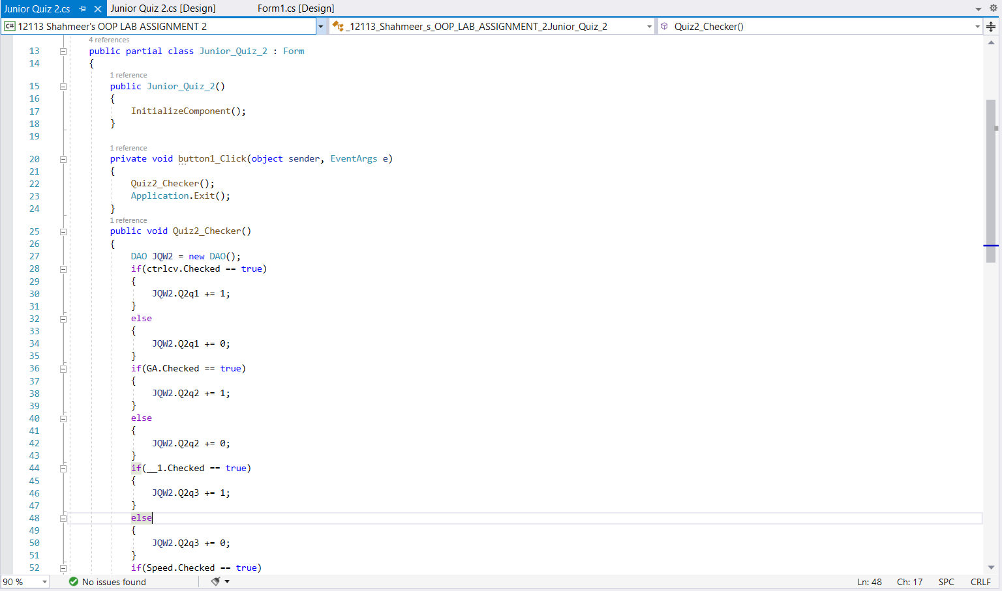

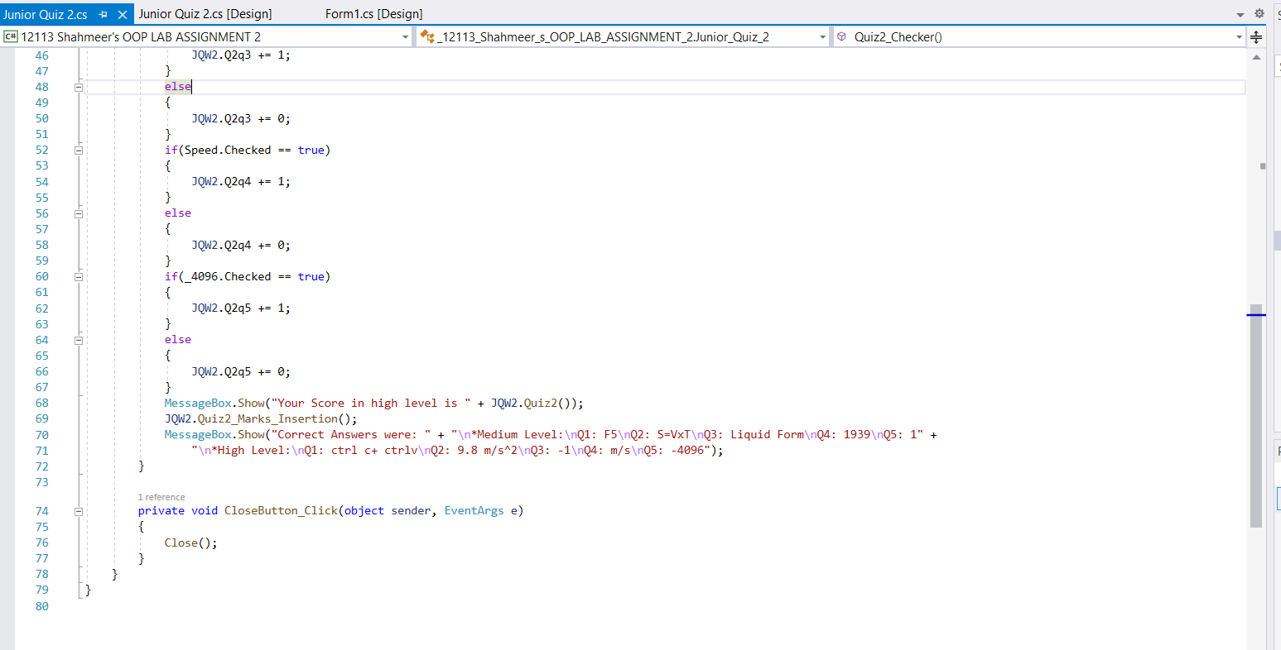

***Senior Quiz 1 Form:***

using System;

using System.Collections.Generic;

using System.ComponentModel;

using System.Data;

using System.Drawing;

using System.Linq;

using System.Text;

using System.Threading.Tasks;

using System.Windows.Forms;

namespace _12113_Shahmeer_s_OOP_LAB_ASSIGNMENT_2

{

public partial class Senior_Quiz_1 : Form

{

public Senior_Quiz_1()

{

InitializeComponent();

}

private void CloseButton_Click(object sender, EventArgs e)

{

Close();

}

private void button1_Click(object sender, EventArgs e)

{

Quiz_Checker();

Senior_Quiz_2 SQ2 = new Senior_Quiz_2();

SQ2.Show();

}

public void Quiz_Checker()

{

DAO SQW1 = new DAO();

if (Pressure.Checked == true)

{

SQW1.Q1q1 += 1;

}

else

{

SQW1.Q1q1 += 0;

}

if (Ohms_Law.Checked == true)

{

SQW1.Q1q2 += 1;

}

else

{

SQW1.Q1q2 += 0;

}

if (Plasma.Checked == true)

{

SQW1.Q1q3 += 1;

}

else

{

SQW1.Q1q3 += 0;

}

if (False.Checked == true)

{

SQW1.Q1q4 += 1;

}

else

{

SQW1.Q1q4 += 0;

}

if (Computer1st.Checked == true)

{

SQW1.Q1q5 += 1;

}

else

{

SQW1.Q1q5 += 0;

}

MessageBox.Show("Your Quiz Total Score is " + SQW1.Quiz1());

SQW1.Quiz1_Marks_Insertion();

}

}

}

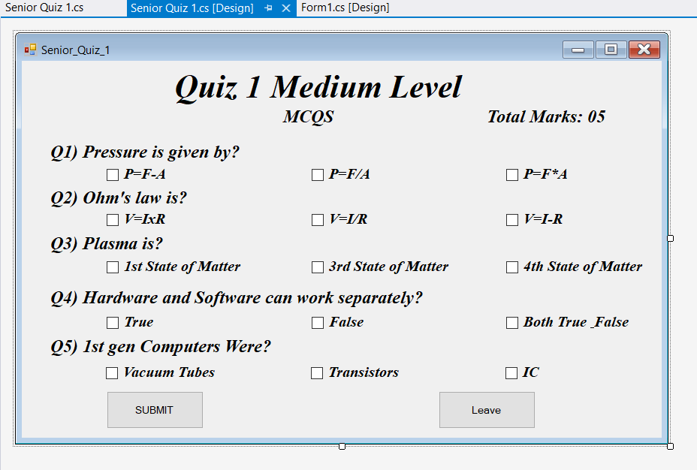

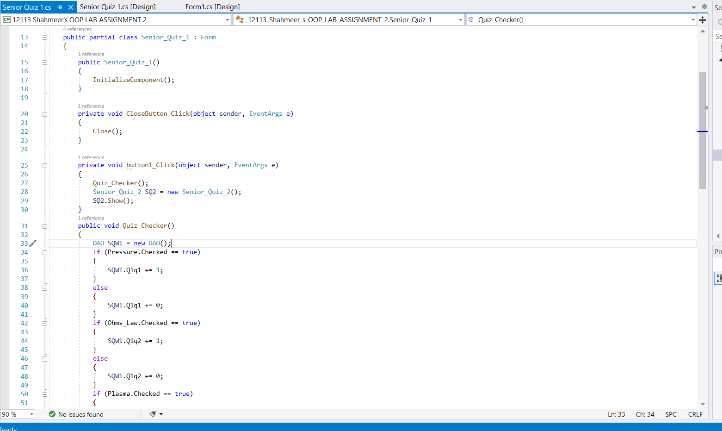

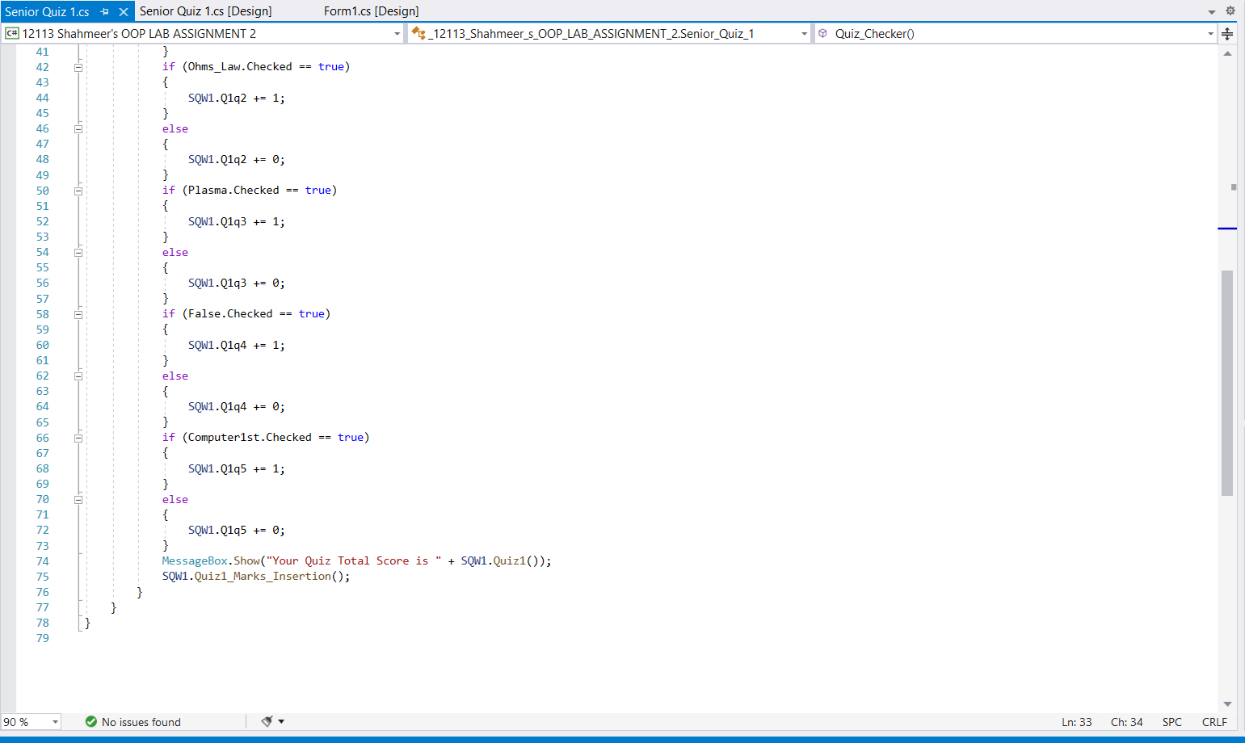

***Senior Quiz 2 Form:***

using System;

using System.Collections.Generic;

using System.ComponentModel;

using System.Data;

using System.Drawing;

using System.Linq;

using System.Text;

using System.Threading.Tasks;

using System.Windows.Forms;

namespace _12113_Shahmeer_s_OOP_LAB_ASSIGNMENT_2

{

public partial class Senior_Quiz_2 : Form

{

public Senior_Quiz_2()

{

InitializeComponent();

}

private void CloseButton_Click(object sender, EventArgs e)

{

Close();

}

private void button1_Click(object sender, EventArgs e)

{

Quiz_Checker();

Application.Exit();

}

public void Quiz_Checker()

{

DAO SQW2 = new DAO();

if (Spiral.Checked == true)

{

SQW2.Q2q1 += 1;

}

else

{

SQW2.Q2q1 += 0;

}

if (temparature.Checked == true)

{

SQW2.Q2q2 += 1;

}

else

{

SQW2.Q2q2 += 0;

}

if (__60.Checked == true)

{

SQW2.Q2q3 += 1;

}

else

{

SQW2.Q2q3 += 0;

}

if (Newton.Checked == true)

{

SQW2.Q2q4 += 1;

}

else

{

SQW2.Q2q4 += 0;

}

if (_5.Checked == true)

{

SQW2.Q2q5 += 1;

}

else

{

SQW2.Q2q5 += 0;

}

MessageBox.Show("Your Score in High level is " + SQW2.Quiz2());

SQW2.Quiz2_Marks_Insertion();

MessageBox.Show("Correct Answers were: " + "\n*Medium Level:\nQ1: P=F/A\nQ2: V=IxR\nQ3: 4th State of Matter\nQ4: False\nQ5: Vacuum Tubes" +

"\n*High Level:\nQ1: Spiral\nQ2: Temparature\nQ3: 60\nQ4: N\nQ5: 0.07");

}

}

}

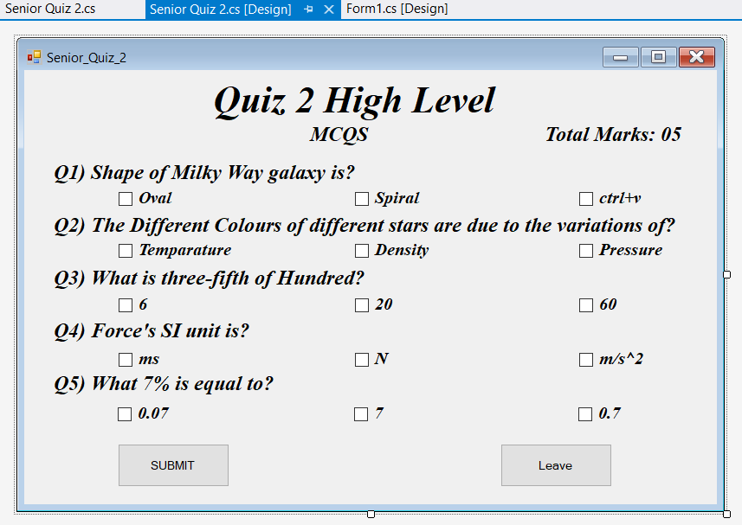

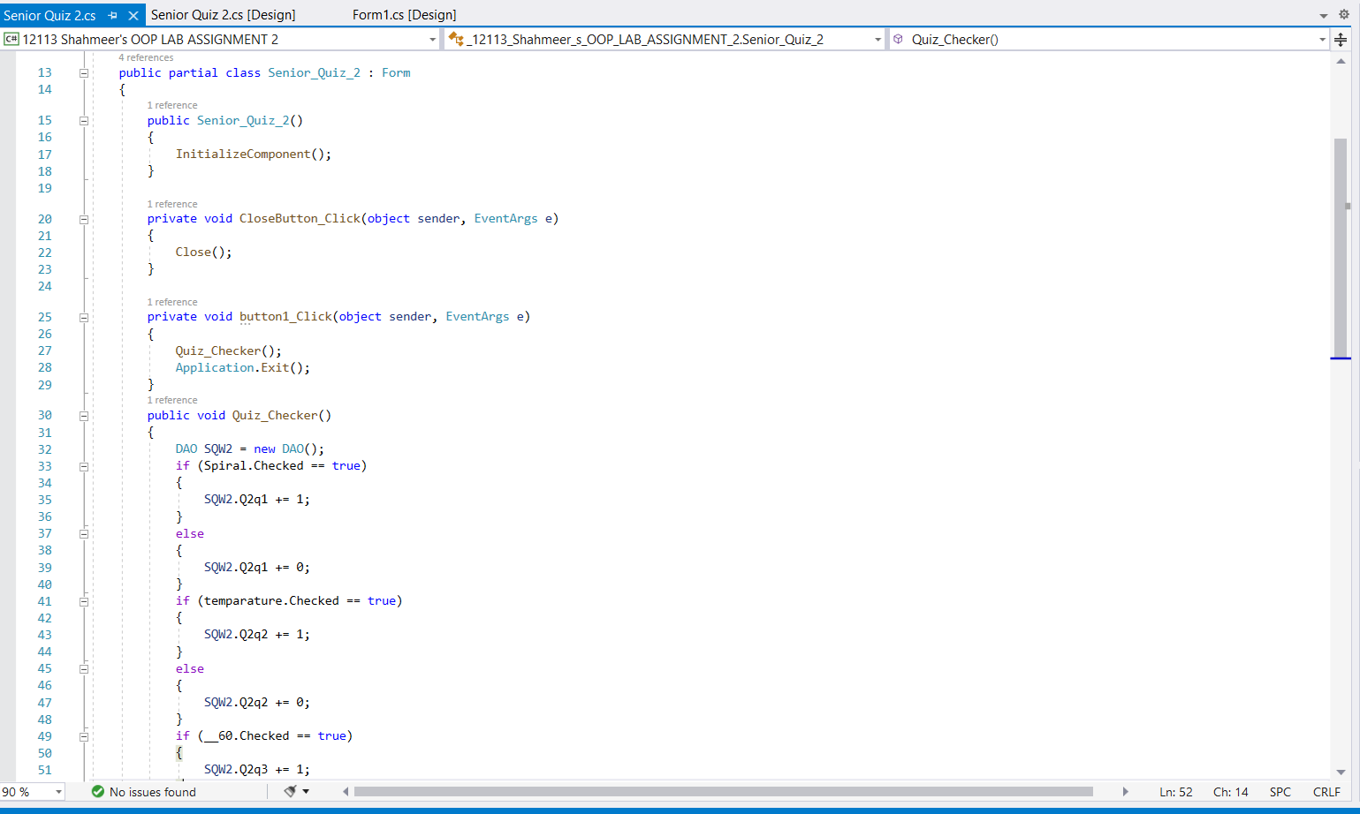

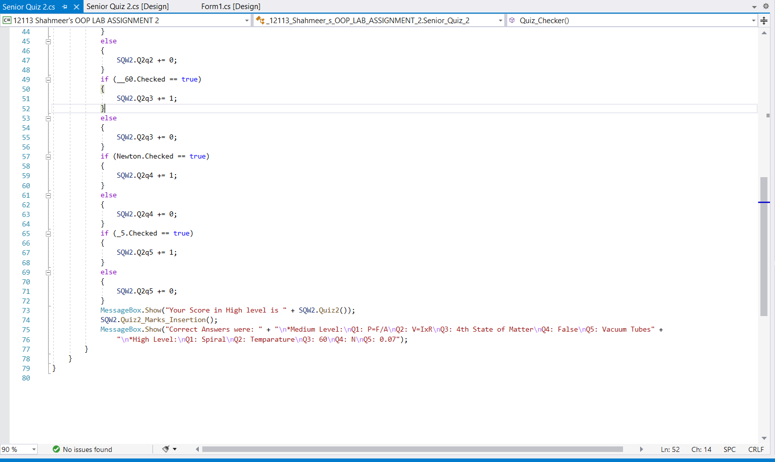

***Output:***

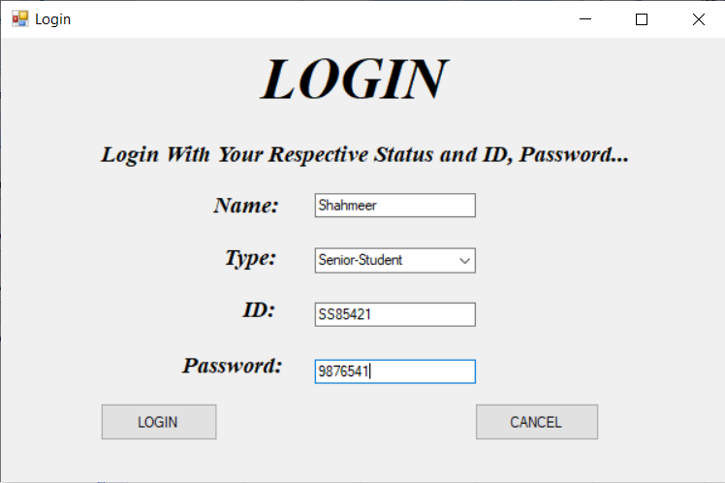

The functioning of this login form 1 page is according to data base’s Table which is this…

It’s Type, ID, Password functioning is done row wise the code is written in dao class in method called Login an overloaded method having polymorphism of method overloading type……

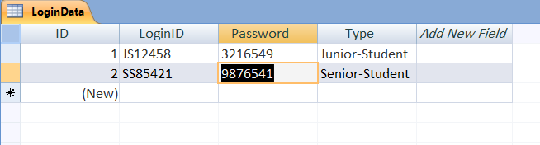

And when we insert the things correctly according to data table and with our name a functioning of marking automatically is also done to mark student’s attendance like to check who logged in for the quiz or not so that data insertion is done in this table of data base….

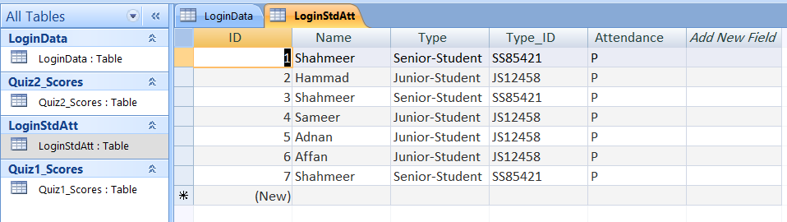

And then the quiz will proceed according to your loggining in data that you entered through the login page if you login with senior student id and password and type then you will be proceeded to senior students quiz thing and I you logins with junior student id and password then you will be proceeded to junior students quiz thing here I logged in with senior student’s id and pass and type so here is my desired output….

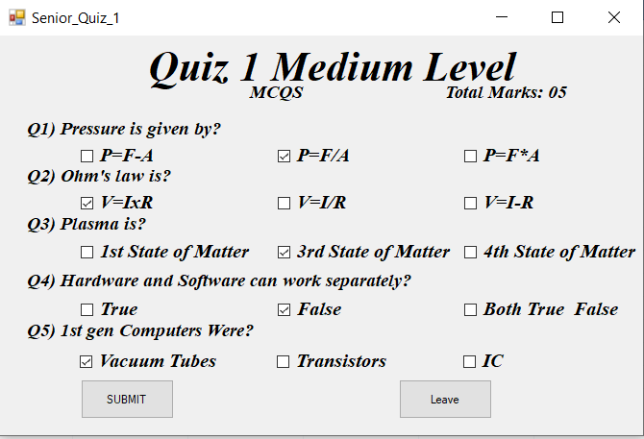

And automatically my score was shown in the messgebox and it also got saved in the database automatically throught the functioning of that dao class int method of Quiz1_MarksInsertion……..

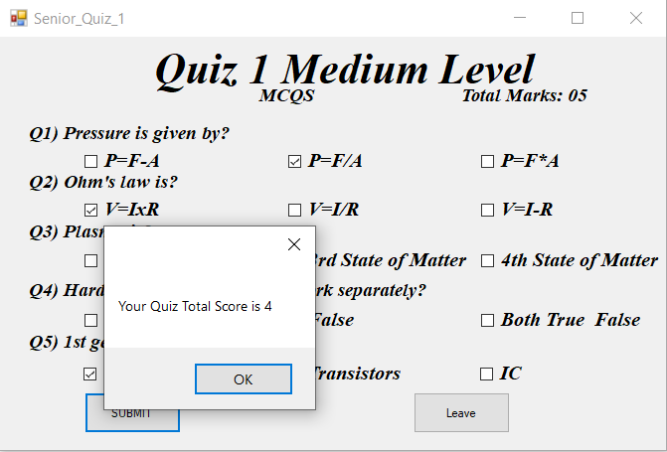

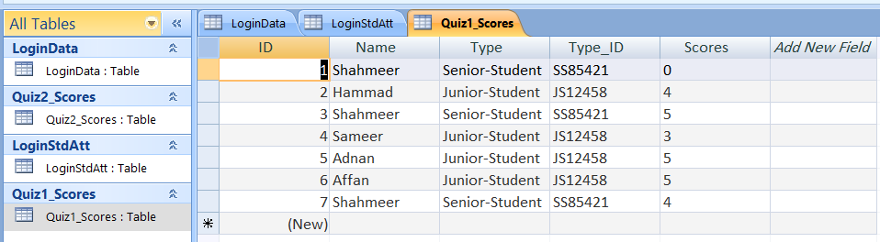

Here on 7th index…..

And then after that The High level Quiz started as soon as I finished the medium level one……

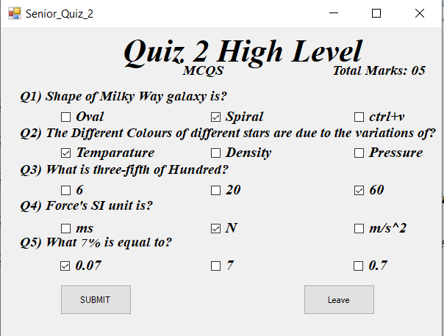

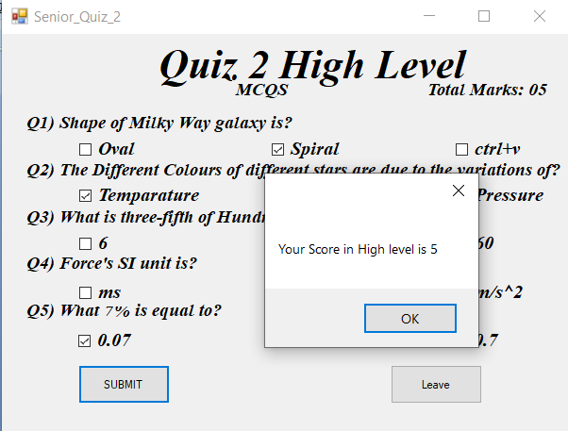

This score also got saved automatically in the data base data table of quiz 2 scores…….

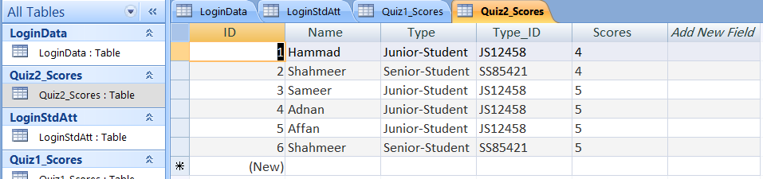

Here on the 6th index row……

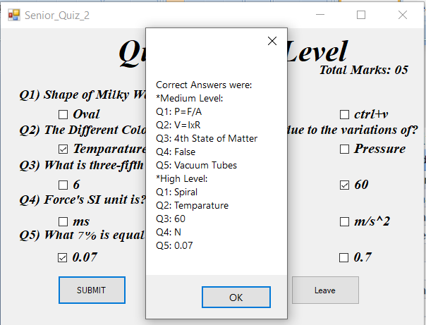

And the correct answers are shown here of both medium and high level quizzes same function will happen if you log’s in with junior student’s id password and type only your type id and type will be differently saved in the data base as “junior-student” in typ and type id will “JS12458”…..

***Ms. Yumna Iftikhar***

# [Add screen shots of code and screen shots of outputs]

**Question – 2 [CONSOLE BASED ] [5 mark]**

Perform the following question and apply appropriate OOP concept.

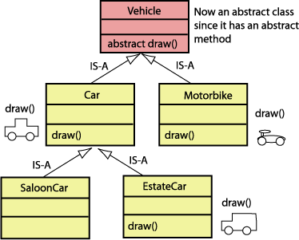

***Inputted Code:***

using System;

using System.Collections.Generic;

using System.Linq;

using System.Text;

using System.Threading.Tasks;

namespace workk

{

class Program

{

static void Main(string[] args)

{

Console.WriteLine("OOP LAB ASSIGNMENT 2");

Console.WriteLine("Question no. 2:");

Motorbike MB = new Motorbike();

MB.draw();

EstateCar EC = new EstateCar();

EC.draw();

EC.EC();

SaloonCar SC = new SaloonCar();

SC.draw();

SC.SV();

Console.ReadKey();

}

}

abstract class Vehicle

{

public abstract void draw();

}

class Car : Vehicle

{

public override void draw()

{

Console.WriteLine("Car class is the child of Vehicle Class, this method is overrided by Car class.");

Console.WriteLine("Car is a four wheel Vehicle and it Moves.");

}

}

class Motorbike : Vehicle

{

public override void draw()

{

Console.WriteLine("MotorBike Class is the child of Vehicle Class, this method is overrided by MotorBike class.");

Console.WriteLine("MotorBike is 2 Wheel Vehicle and it Moves.\n");

}

}

class SaloonCar : Car

{

public void SV()

{

Console.WriteLine("This is Saloon car class child of car class.\n");

}

}

class EstateCar : Car

{

public void EC()

{

Console.WriteLine("This is EstateCar class child of Car class.\n");

}

}

}

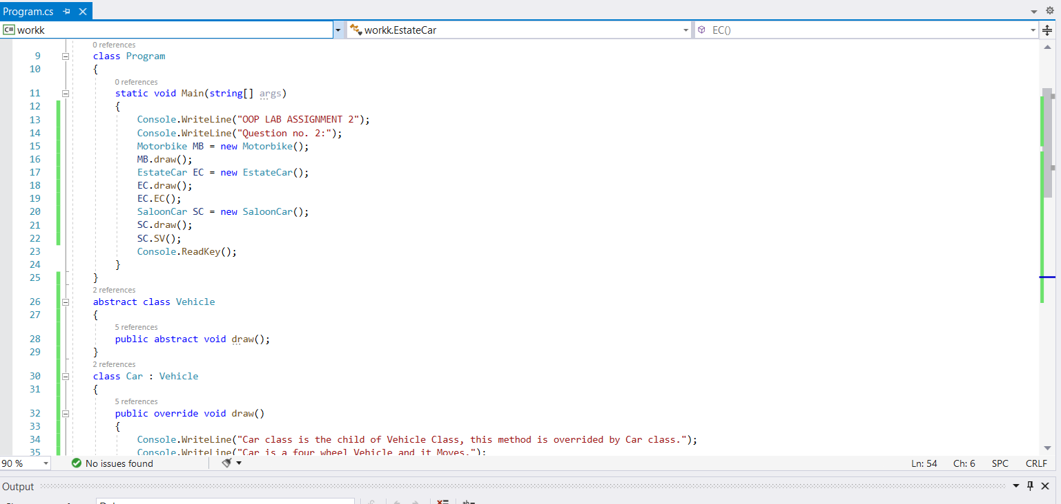

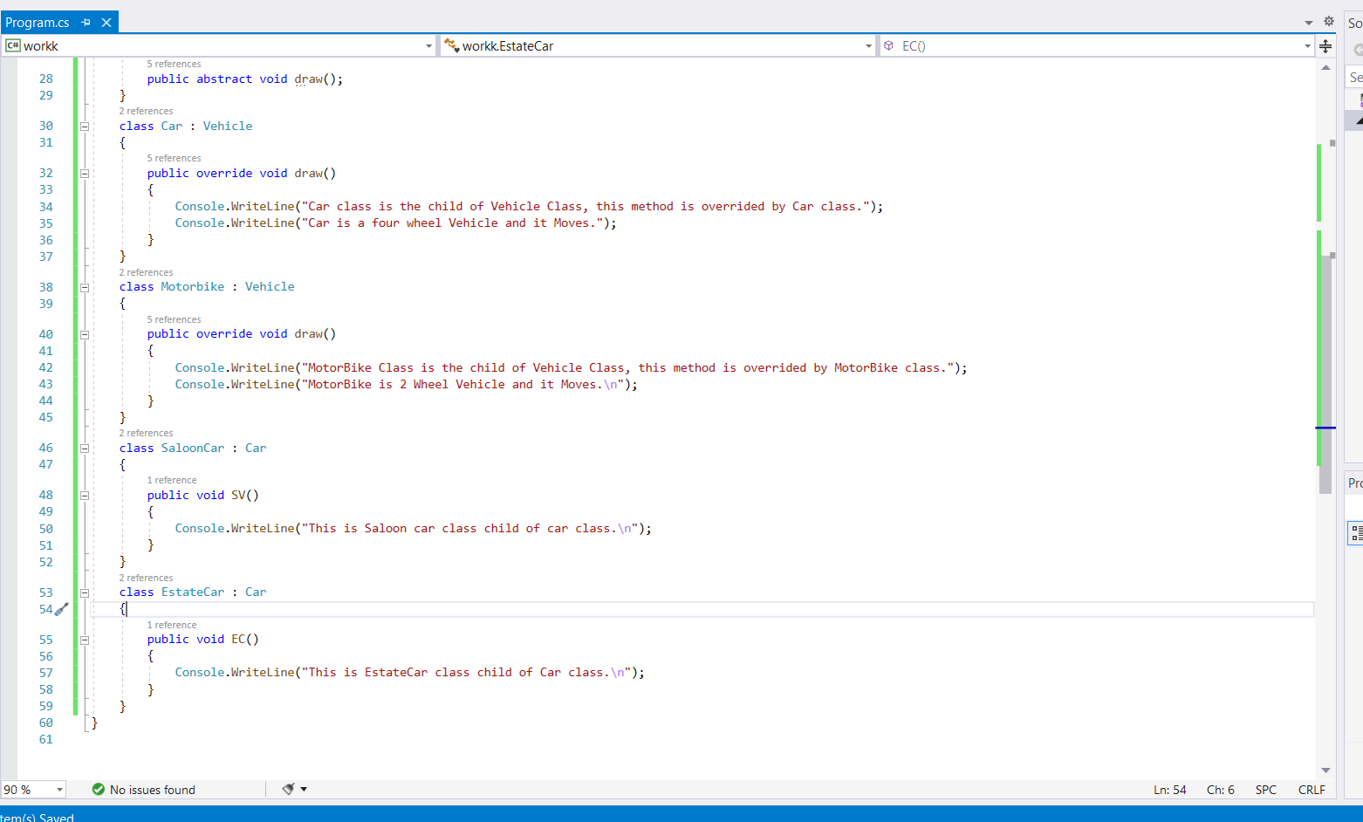

***Output:***

